# **TESTING REQUIREMENTS FOR SMART RECIPE RECOMMENDER**

**Unit Testing**

**Component Testing:**

* All React components (recipe cards, filter buttons, search bar, popups) were tested manually to ensure they render and behave correctly.
* Button functionalities like filtering by tag, sorting recipes, saving favorites, and deleting recipes were verified across different states.

**APIs:**

* Login and Signup APIs were tested with valid and invalid inputs.
* Recipe-related APIs (add recipe, update recipe, delete recipe, fetch recipes) were thoroughly tested.
* API calls returned correct responses, authentication tokens, and proper error messages on failures.

**Business Logic:**

* Recipe filtering and sorting functions (e.g., by cuisine type, prep time, popularity) work as expected.
* Saved recipes and favorites update correctly in both the UI and the database.

**Integration Testing**

* Basic integration testing between frontend components and backend APIs was conducted manually.
* After login/signup, user-specific recipes and preferences are fetched and displayed properly without full page reloads.
* Navigation between Home, Inventory, Chatbot, Recipes, and About sections works seamlessly.

**Test Report**

**What Was Tested:**

* All major frontend components and user flows.
* Authentication flows (Login, Signup).
* Recipe management operations (Create, Update, Delete, Fetch).
* Filtering, sorting, and saving functionality.
* Responsiveness on different devices (Mobile, Tablet, Desktop).

**Tools Used:**

* Postman for API Testing.
* Manual Testing for UI and user experience validation.

**Summary of Results:**

* All tested components, APIs, and flows worked correctly for valid use cases.
* Proper error handling was observed for invalid API requests.
* No critical bugs found during manual testing.
* Responsive design and consistent UI rendering confirmed across devices.
* Smooth login/signup authentication and reliable recipe management experience.

**Screenshots:**

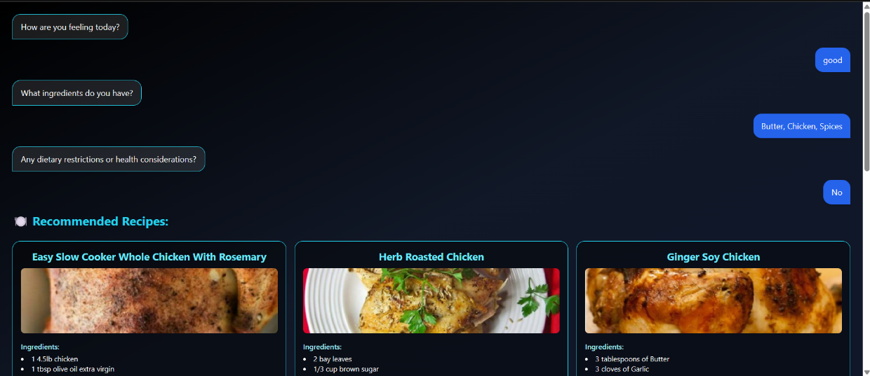

**Fig no 1**

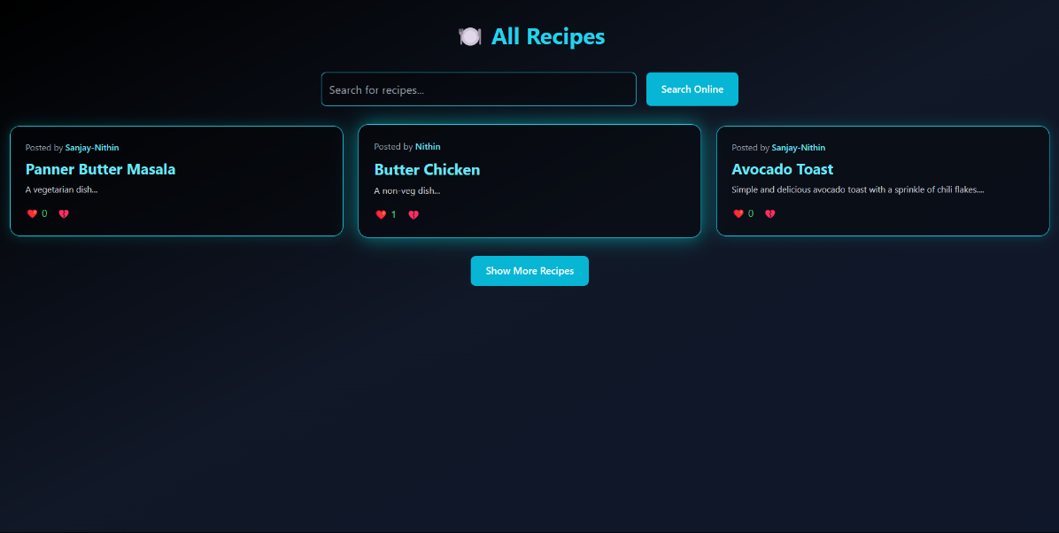

**Fig no 2**

**Test phase:**

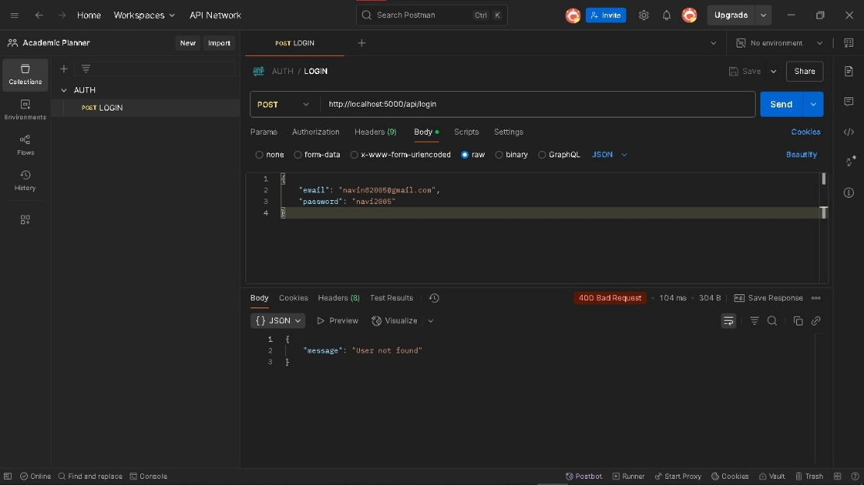

**Fig no 3**

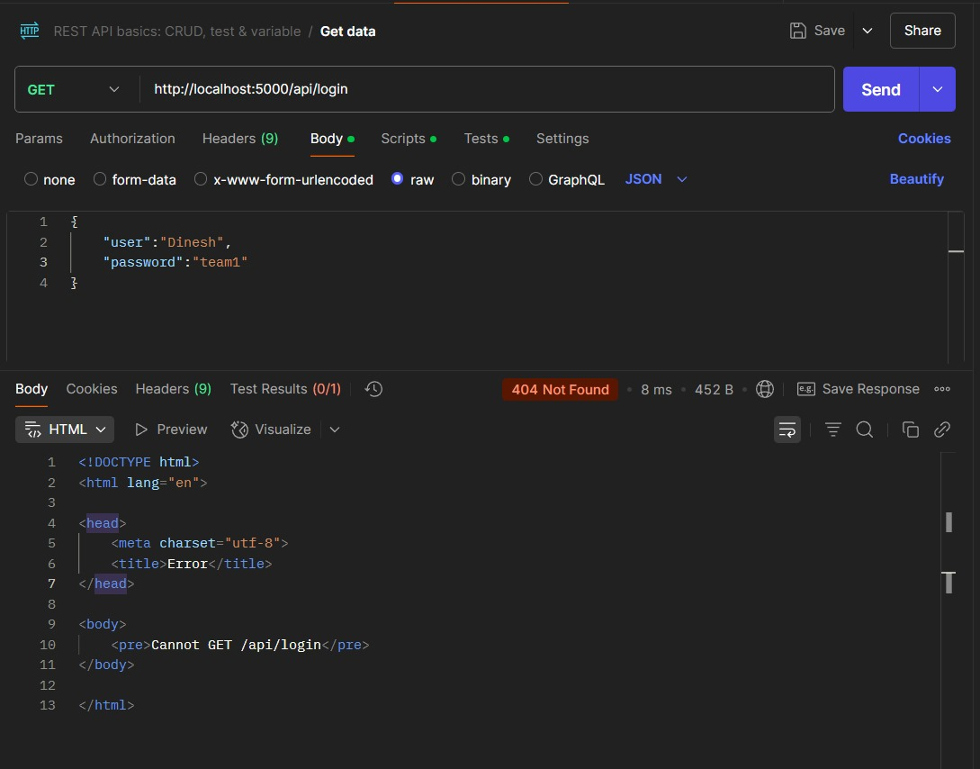

**Fig no 4**